insert into abalone

(gender, length, diameter, height,whole_weight,shucked_weight,viscera_weight,shell_weight,rings,collector,water_region,feb_temp)

values('M','0.71','0.555','0.195','1.9485','0.9455','0.3765','0.495','12','Jan Odom, University of Houston','Florida Atlantic Coast',' 71.8 degrees Fahrenheit');

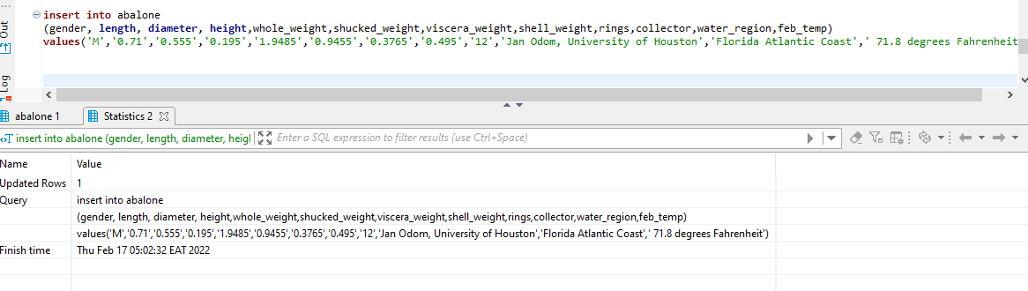

select * from abalone where collector = 'Jan Odom, University of Houston';

